Scheduling
The Master beacon repeatedly send out requests with a beacon id encoded in it. When transponders get the request, they check if the encoded id is the same as their own id and the decide whether to respond.
The Master beacon will immediately send request with next id after receiving a response from the previously requested transponder. Otherwise it will wait for a certain period until it send request with next id.
Timing
The timer driven transmission (tx) buffer and receiving (rx) ADC buffer are synchronized so that they take same to be write/read, and the start writing/reading at the same time.
As shown below, the whole signal package spans for 4 buffer length of the digital transmission (tx) buffer. Due to the limit if the computational speed of the stm32 board, the firmware start loading the data to the tx buffer after current half of rx and tx buffer being fully processed. Then it takes about 3 quarters of buffer for the sonar actuator to start sending the signal. The rx buffer processor will be switched to deactivated mode from the time when a recognizable data package is received to the time when the next transmission is finished. The deactivation is to avoid reading the vibrations from its own sonar actuator. Specifically for the transponder, if the id in the received data package does not match its own id, the rx processor will not be deactivated.
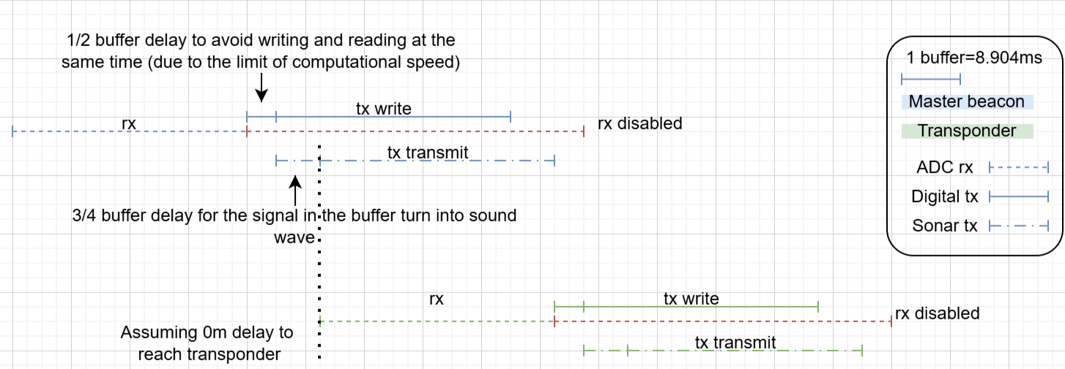
Limits
The most critical limit of current hardware is the lack of dedicated phase lock loop module. The programmed digital phase lock loop takes too much CPU cycles to run and its slower than the speed of incoming ADC readings. Hence there is a 512 buffer gap between every bits of transmitted data.
Furthermore, because the phase lock loop has to skip a large proportion of ADC readings to keep up with the speed, multipath estimation which requires all time phase profile is unavailable.
The hardware dose not support modification to the transmission power. Therefore, only receiving gain is increased as the range increases and the received signal power drops. This hardware limit leads to a critical problem that the noise is also magnified as receiver gain is tuned up. The most significant noise found in experiment comes from the echo of the beacon’s own tx signals. The power of echo drops exponentially as the surface reflecting the signal gets further. Since the environment is unpredictable, an additional rx disabling time is used after sending any signals. Meanwhile, the transponder also waits for the same delay before sending the response. This is one of the main factors that limits the data rate of the whole system.
The other factor limiting the data rate also comes from the echo of the tx signal. Because the experimenting environment are surrounded by solid vertical walls. The first arrived signal is usually interfered by multipathing with the similar amplitude. For phase keying communication, when the signal to noise ratio is too small, multipath estimation breaks because the noise shifts the phase of signal so much and wrap around 360 degrees. So, to avoid the multipath interference, a simple silence delay is added after every single bit of data. If the multipath interference can be solved, the data rate would increase by 64 times.

